HANDS ON 4
TASK 1
EXPLAIN SELECT s.first_name,s.last_name,c.course_name FROM enrollments e JOIN students s ON s.student_id=e.student_id JOIN courses c ON c.course_id=e.course_id WHERE s.enrollment_year=2022;

TASK 2
CREATE INDEX idx_students_enrollment_year ON students(enrollment_year);
CREATE UNIQUE INDEX idx_enrollment_unique ON enrollments(student_id,course_id);
CREATE INDEX idx_course_code ON courses(course_code);
EXPLAIN SELECT s.first_name,s.last_name,c.course_name FROM enrollments e JOIN students s ON s.student_id=e.student_id JOIN courses c ON c.course_id=e.course_id WHERE s.enrollment_year=2022;
CREATE INDEX idx_student_grade ON enrollments(student_id,grade);

EXPLAIN SELECT * FROM students;

CREATE UNIQUE INDEX idx_enrollment_unique ON enrollments(student_id,course_id);

TASK 3
N+1 PROBLEM
import mysql.connector
import time
conn = mysql.connector.connect(
host="localhost",
user="root",
password="root",
database="college_db"
)
cursor = conn.cursor()
start = time.time()
cursor.execute("SELECT * FROM enrollments")
enrollments = cursor.fetchall()
query_count = 1
for row in enrollments:
cursor.execute(f"SELECT first_name,last_name FROM students WHERE student_id={row[1]}")
cursor.fetchone()
query_count += 1
end = time.time()
print("Queries Executed:", query_count)
print("Execution Time:", end-start)
cursor.close()
conn.close()

OPTIMIZED SINGLE JOINQUERY
import mysql.connector
import time
conn = mysql.connector.connect(
host="localhost",
user="root",
password="root",
database="college_db"
)
cursor = conn.cursor()
start = time.time()
cursor.execute("SELECT e.enrollment_id,s.first_name,s.last_name,c.course_name,e.grade FROM enrollments e JOIN students s ON e.student_id=s.student_id JOIN courses c ON e.course_id=c.course_id")
rows = cursor.fetchall()
end = time.time()
print("Queries Executed: 1")
print("Execution Time:", end-start)
for row in rows:
print(row)
cursor.close()
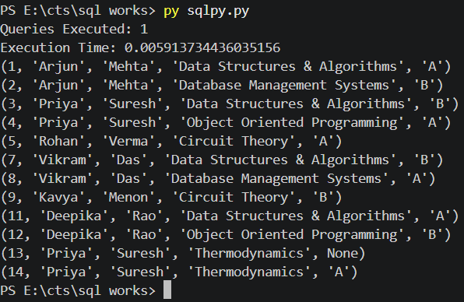
conn.close()

